PROJECT DEVELOPMENT PHASE

DELIVERY OF SPRINT 4

|  |  |
| --- | --- |
| Date | 13 November 2022 |
| Team ID | PNT2022TMID24184 |
| Project Name | Project – Personal Assistance for senior citizens who are self-reliant |

SPRINT IV:Software Implementation

Objective:

Converting the data received from cloud as voice using IBM Text to Speech service

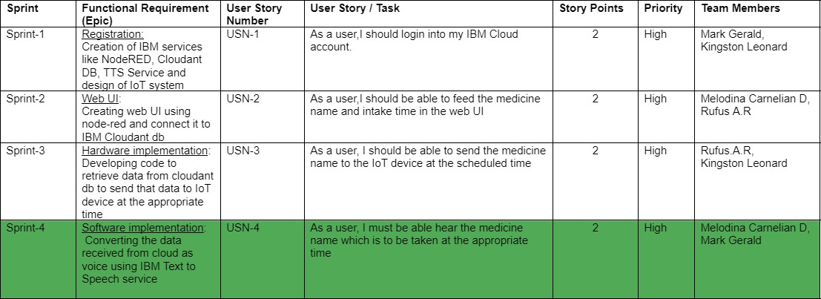

* **Creating a function to convert the medicine name in object format to string format :**

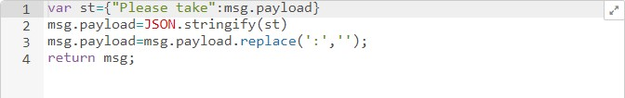

* **Creating and configuring IBM Text-to-Speech node:**

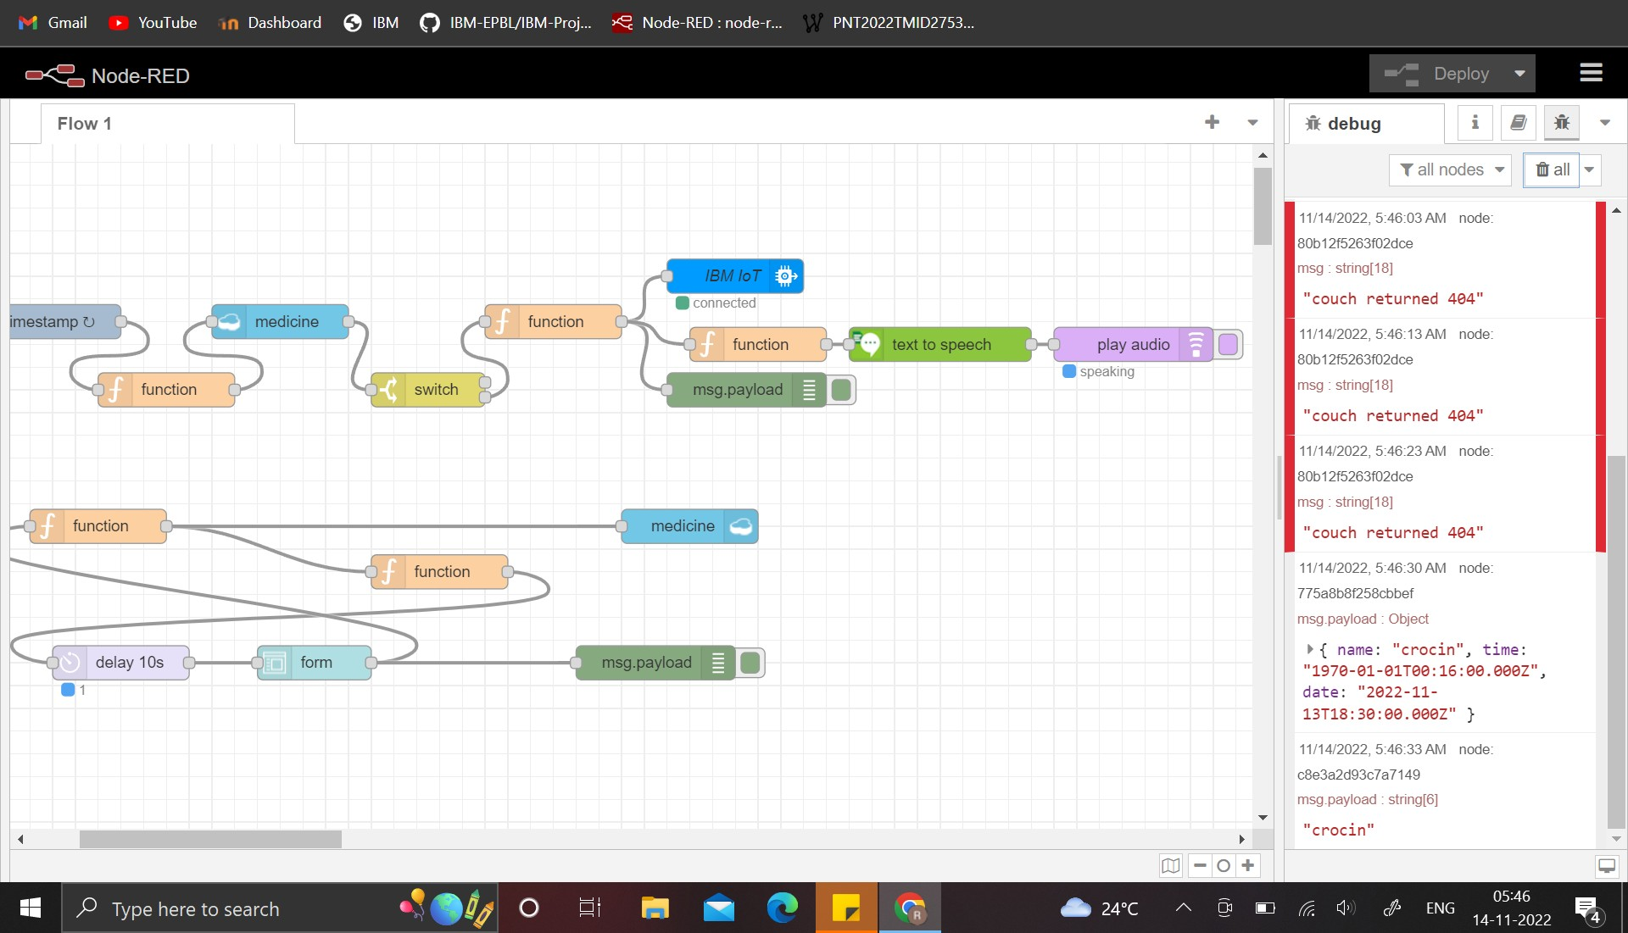



* **APP UI CREATED MIT APP INVENTOR:**

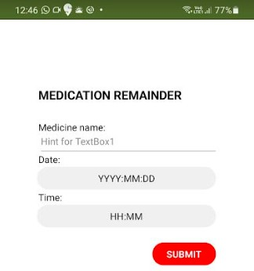

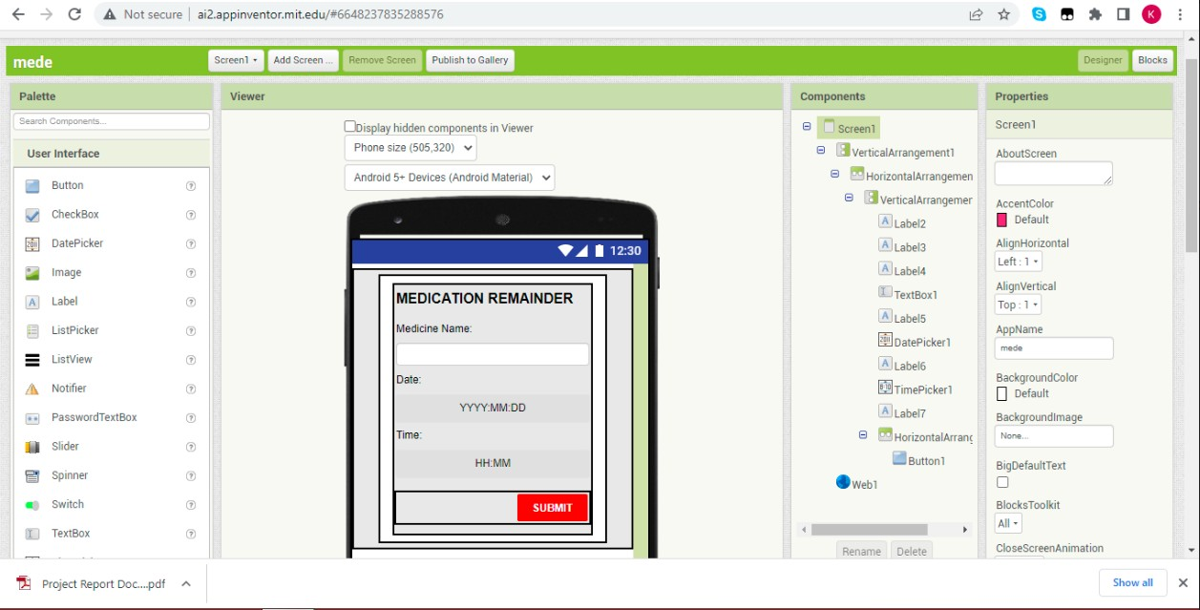

The software implementation is successfully completed

**\*\*\*\*\*\*\*\*\*\*\*\*\*\*\*\*\*\*\*\*\*\*\*\*\*\*\*\*\*\*\*\*\*\*\*\*\*\*\*\*\*\*\*\*\*\*\*\*\*\*\*\*\*\*\*\*\*\*\*\*\*\*\*\*\*\*\*\*\*\*\*\*\*\*\*\*\*\*\*\*\*\*\*\*\*\*\*\*\*\*\*\*\*\*\*\***